VMware vCenter Server (VCS) Converter Appliance Fling Documentation
The VCS to VCSA Converter Appliance is the 2013 Fling Contest winning idea. It allows customers to migrate from Windows vCenter Server with an External Microsoft SQL Server Database to the vCenter Server Appliance with an embedded vPostgres database. The Fling migrates the vCenter database, roles, permissions, privileges, certificates and inventory service. The target appliance will run at the same IP address as the source vCenter. Please see the Fling webpage https://labs.vmware.com/flings/vcs-to-vcva-converter for more details.

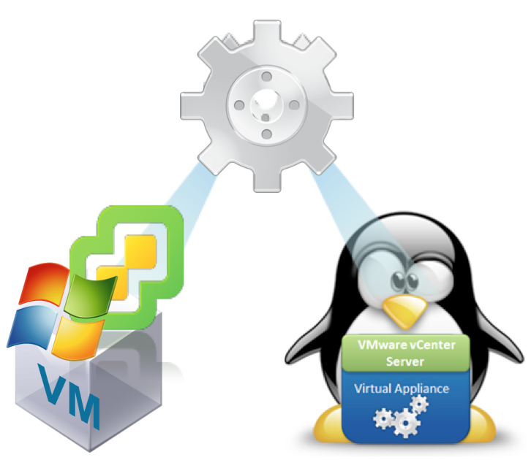

Change Log:
- v0.9 – Initial release

System Requirements:
- vCenter Server running on Windows - vSphere 5.5 or greater
- The Windows vCenter Server and the vCenter Server Appliance should be running the same version (e.g. vCenter Server Windows 5.5u1 to VCSA 5.5u1)
- The vCenter Server Appliance should be deployed with at least the same number of CPUs and at least the same amount of memory as the Windows vCenter Server host
- vCenter Components (Inventory Service, vSphere Web Client and VMware Single Sign On) must be running on the same host as the vCenter Server
- External Microsoft SQL Server 2008R2 or later for the vCenter Database (VCDB)
- vSphere Web Client Plugins connected registered with an Active Directory user
- VMware Single Sign On User/Groups are currently not migrated (require re-registration)
- Migration Appliance must be able to communicate with the Windows vCenter Server Database and its database as well as the new vCenter Server Appliance. The following ports are used for this communication and should be open on the vCenter Windows server and on the VCSA:
  - Ports: 22 (ssh), 443 (https), 445 (SMB)

Limitations:
- Microsoft SQL Server and vCenter Server must be on separate hosts
- Microsoft SQL Express Database is not supported in version 0.9
- VMware Single Sign On Users and Groups are not migrated in version 0.9
- Windows Local Users and Groups are not migrated in version 0.9
- vCenter Alarm action scripts are not migrated in version 0.9
- The migration will require some downtime for the vCenter Server
- Linked Mode configuration is not migrated. Multiple vCenters must be migrated separately
- Any VMware or 3rd party vSphere Web Client plug-ins (e.g. VUM, NSX) that are running on the same host as the vCenter Server will not be migrated

Prerequisite Information Required:
- Administrator credentials to host where vCenter Server is running
- Credentials to Windows vCenter Server (username and password)
- Credentials to vCenter Server Database (username, password and DB Name)
- Credentials for all vSphere Web Client Plugins used for registration (username and password)
- Sufficient storage to deploy the vCenter Server Appliance
- The vCenter server appliance must be on the same network as the vCenter Windows server, and will use the same IP address.

Diagram to visualize the migration process:
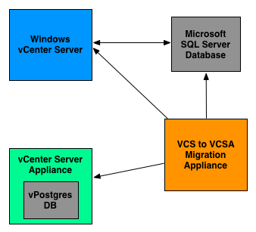

VCS to VCSA Migration Instructions:

Note: If at any point the migration fails; you can continue managing your environment with the Windows vCenter Server.

- Verify your credentials for the vCenter Server, vCenter Server Database, and any solutions or Web Client plugins that you are using.

- Shut down or disable any solutions or Web Client plugins that you are using. In our example, we use VMware NSX and VMware Update Manager; Figures 1 and 2 demonstrate shutting down these solutions.

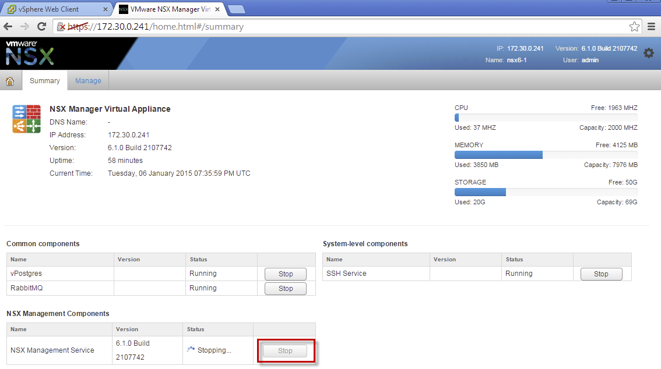
Figure 1 - Stopping NSX service

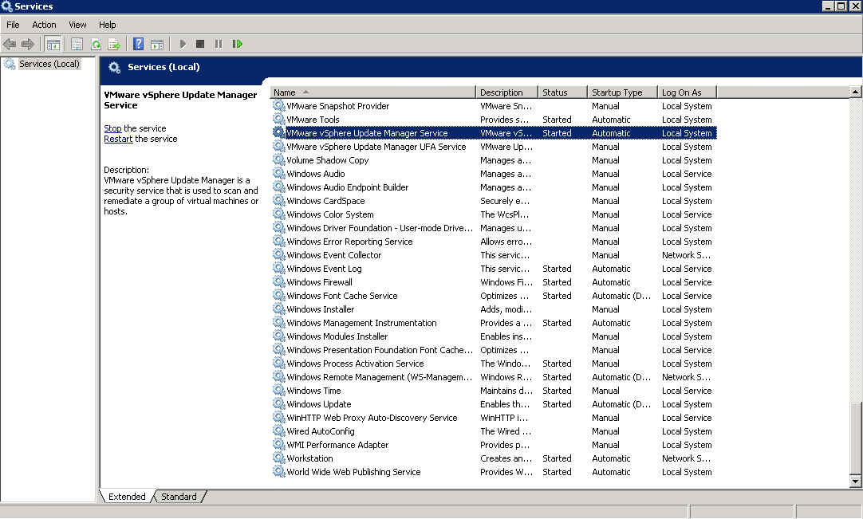
Figure 2 - Stopping vSphere Web Client Plugin Services

- Deploy the VCS to VCSA Converter Appliance into your environment, and power it on. Ensure that the appliance can connect to your vCenter Server, your vCenter Server Database, and your new vCenter Server Appliance over the network.

- Once the Converter Appliance has powered up, you should see the following screen, prompting for network configuration of the appliance. By default it will try to configure itself using DHCP, but you have the option of setting a static IP Address.
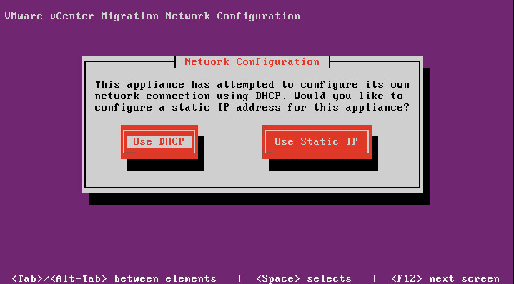
Figure 3 - Network configuration of appliance
- If static IP assignment is selected, you will need to fill out the following properties:
  - IP Address
  - Subnet mask
  - Default gateway
  - DNS Server
  - DNS search suffix

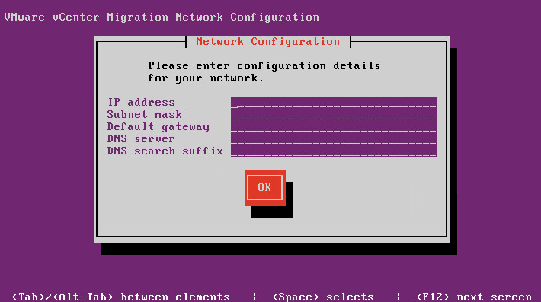
Figure 4 - Static IP configuration
Once you have completed the network configuration screen, go ahead and enter ok for the changes to be applied.

- The next screen will be the start of the migration wizard. Take a moment to carefully read through the instructions. For more details, take a look at the next section.

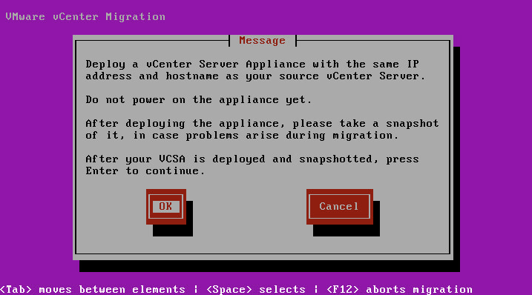
Figure 5 - Deploy powered off VCSA

Deploy the same version of the VCSA as the Windows vCenter Server using the same hostname and IP Address as your source Windows vCenter Server. Do not power on the VCSA yet. Take a snapshot in case problems arise during the migration and you need to reset the appliance to a clean state.

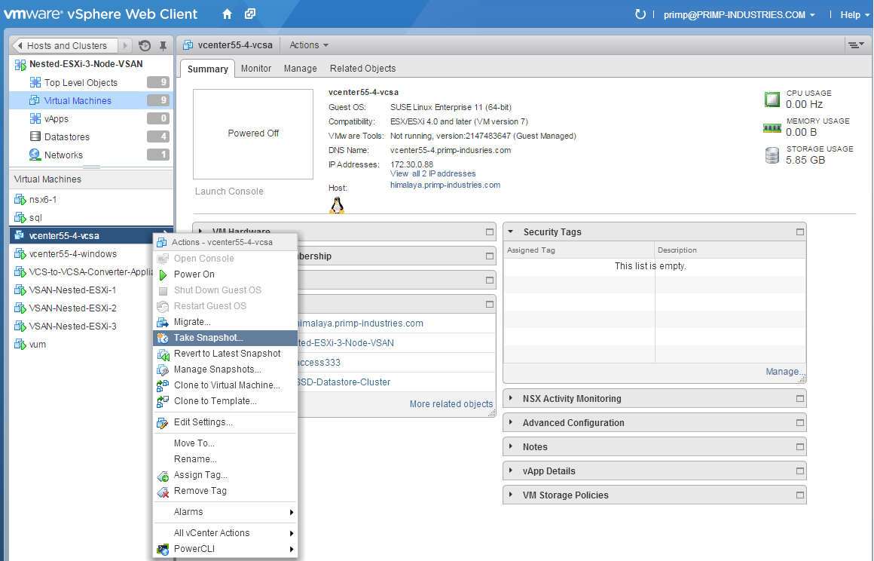
Figure 6 - Create snapshot of VCSA after deployment
- Once you have finished deploying the VCSA, you may proceed to the next step in the VCS Migration Appliance wizard. You will be asked to enter the IP or Hostname of the Windows vCenter Server along with the Windows Administrator credential.
Note: Be sure to provide credentials for a Windows administrator, not a vCenter administrator.
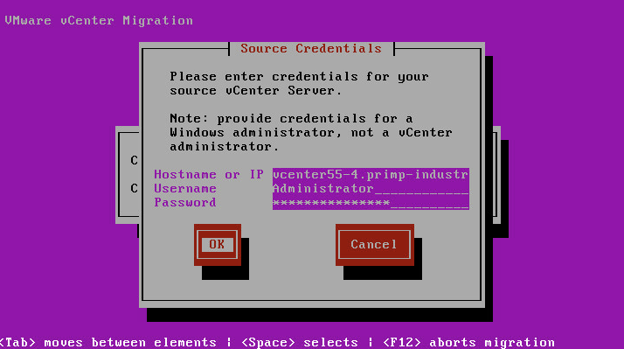
Figure 7- Enter Windows vCenter Server credentials
During this step, vCenter data and configuration information is copied over to the Converter Appliance.

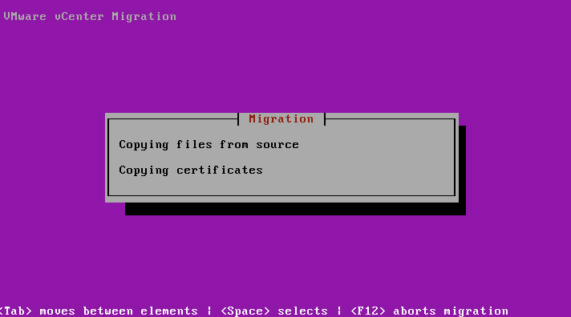
Figure 8 - Copying files from Windows vCenter Server

- Next, power off your Windows vCenter Server machine, and when it is off, power on the VCSA. Do not login to the VCSA administrator interface on port 5480 this is because the Windows vCenter Server and the VCSA is using the same IP Address. Once the VCSA is powered up and showing its blue console, select OK to continue to the next step in the VCS Migration Wizard.

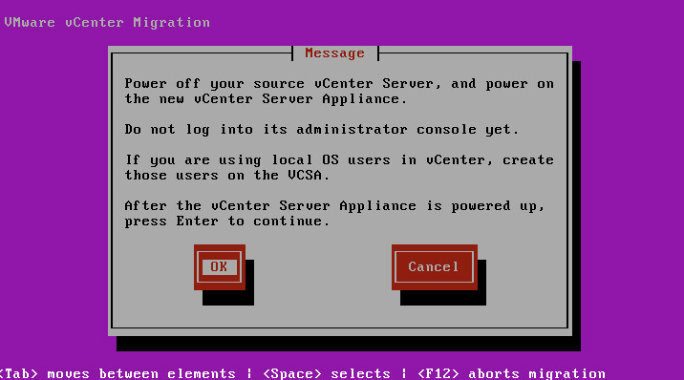
Figure 9 - Power off Windows VC and power on VCSA

- If the VCSA has not finished booting, the Converter Appliance will wait for it. When the VCSA has finished booting, the Converter Appliance will ask you to verify the SSH public key presented by the VCSA. If you would like to verify the key presented by the VCSA, follow the instructions given by the Converter Appliance. Continue by selecting “Yes”.

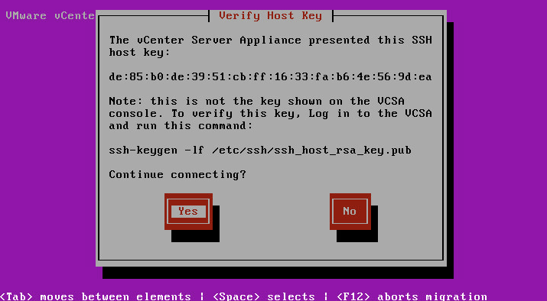
Figure 10 - SSH host key acceptance

- Next, you will need to enter the root password of the VCSA. This should be “vmware” unless you have changed it.

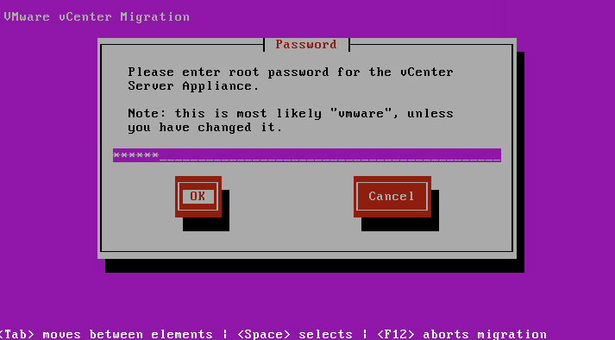
Figure 11 – Enter VCSA root password

During this step, the Windows vCenter Server configurations and other files are being restored into the VCSA.

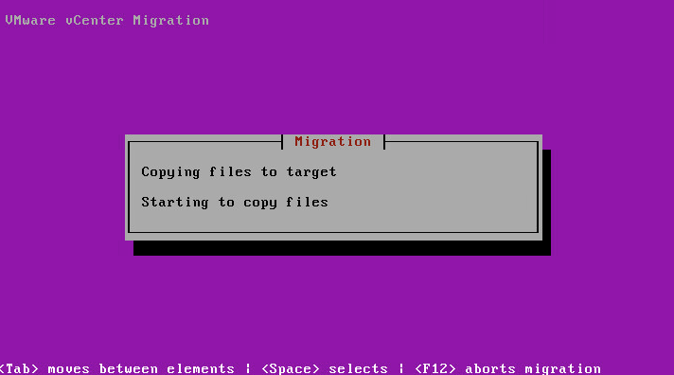
Figure 12 - Copying files to VCSA
- Enter your DNS Domain suffix (e.g. yourcompany.com) and hit OK to continue. Note that the Converter Appliance may fill this in with its best guess for your default DNS suffix. If the prefilled answer is incorrect, or you do not wish to configure the DNS search suffix, feel free to edit or delete the suffix given.

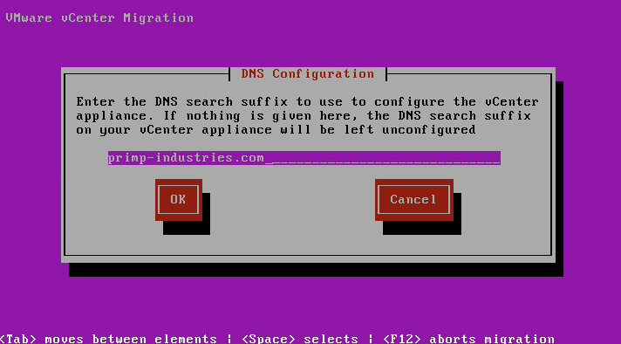
Figure 13 - Enter DNS Domain
We will now configure the destination VCSA. To begin this process, open up a new browser window and point it at the VCSA Virtual Appliance Management Interface (VAMI) on port 5480. The URL is shown on the Converter appliance console

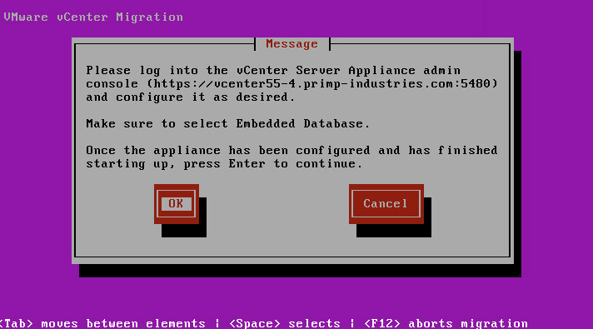
Figure 14 - Configure VCSA using VAMI

Connect to the following address: https://[VCSA-IP]:5480. Log in as root, using vmware as the password unless you have changed it.
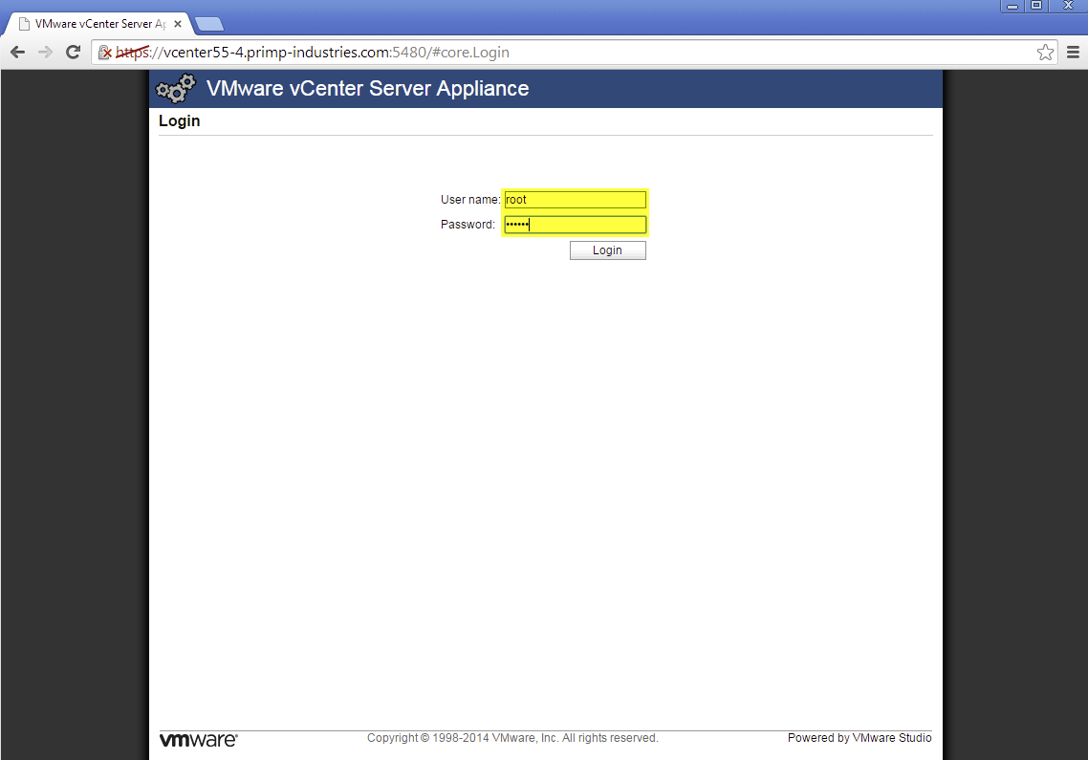
Figure 15 - Login to VAMI

- Configure the VCSA using the VAMI.
- First, accept the EULA and click Next to continue.
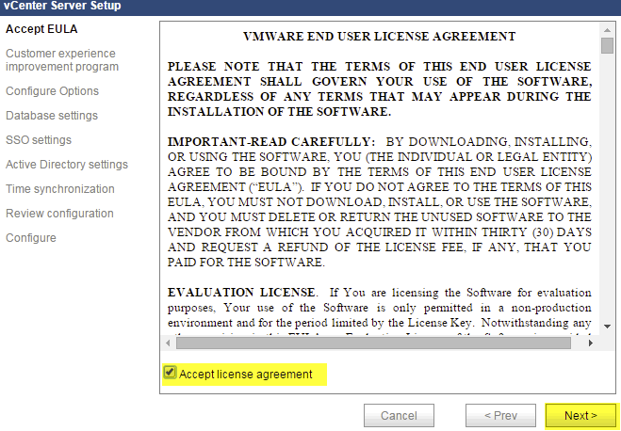
Figure 16 - VAMI Eula
- Enable the VMware Customer Experience Program if you wish. Click Next to continue.
- Select “Set Custom Configuration” and click Next to continue.
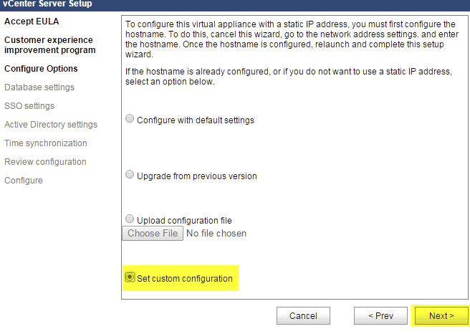
Figure 17 - VAMI Configure Options
- Select the default “Embedded” database and click Next to continue.
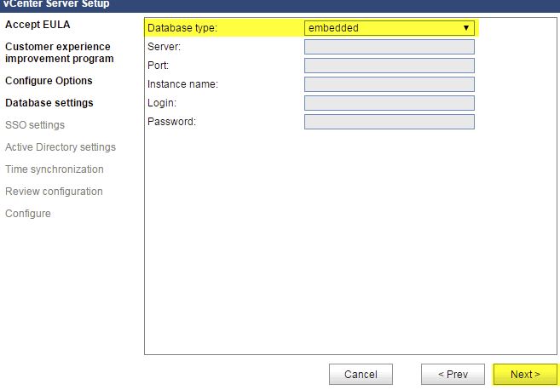
Figure 18 - VAMI Database settings
- Select the default “embedded” SSO deployment type. Enter a password for the SSO Administrator account and then click Next to continue.
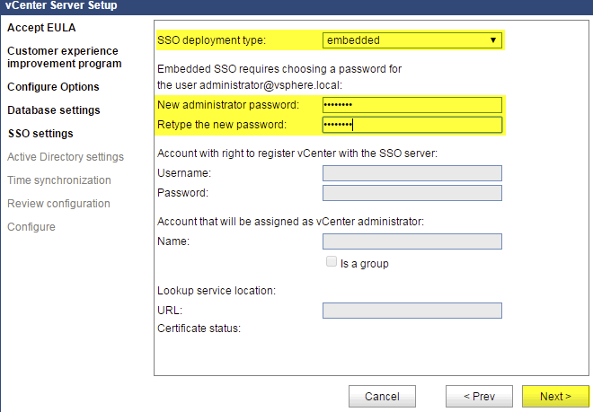
Figure 19 - VAMI SSO Database settings
- If you are using Active Directory in your environment and would like to join the VCSA to your AD domain, check the box for “Active Directory Enabled”, and enter your AD domain and credentials. You may need to remove the previous AD object in your AD database. If you aren’t using Active Directory, just click Next.
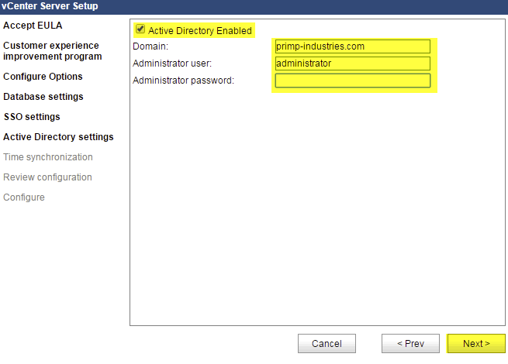
Figure 20 - VAMI Active Directory settings
- The next screen is a review of your configuration. You can go back and make changes, or click Next to start the appliance configuration.
- If you do not have Active Configured, it is highly recommend you provide an NTP Serer for time synchronization.
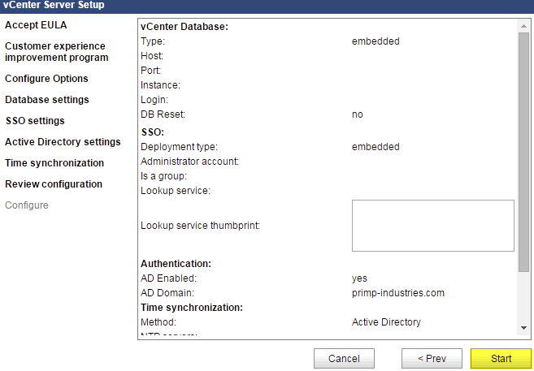
Figure 21 - VAMI Summary
- The VCSA configuration can take several minutes. If everything was successful you will see green checkmarks next to all of the configuration items, as in Figure 20.
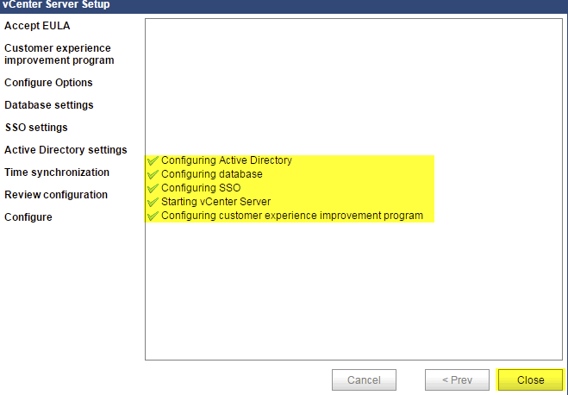
Figure 22 - VAMI configuration complete

- Once the VCSA has finished configuring, go back to your Converter Appliance and select OK to proceed to the next step. You can now close the VCSA browser window. Once a connection can be made to the VCSA, you should be prompted to accept the SSL certificate fingerprint. The fingerprint is shown on the VCSA console. Select “Yes” to accept to continue to the next step.

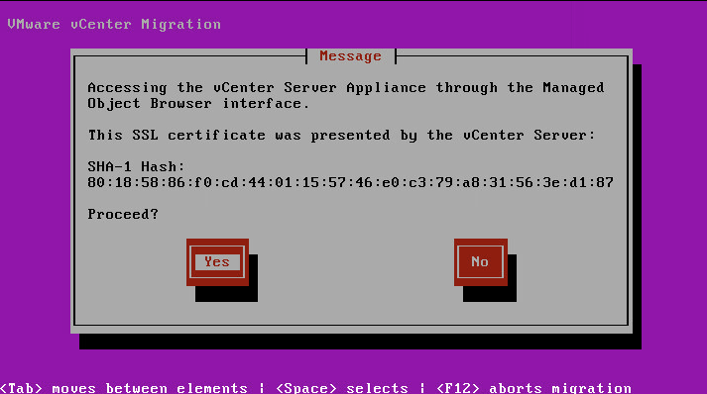
Figure 23 - Accept VCSA SSL certificate fingerprint
- Next, enter the new vSphere SSO Administrator password that you had configured earlier in step 12e and hit OK to proceed to the next step.

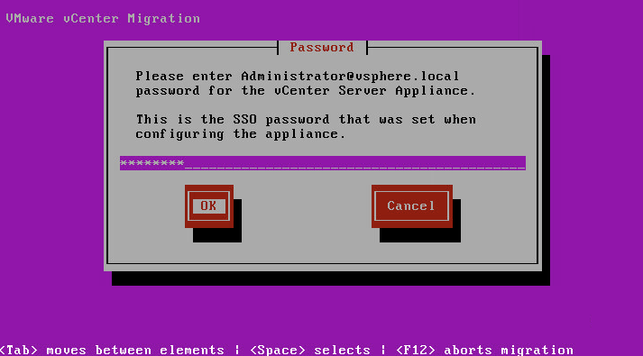
Figure 24 - Enter new vSphere SSO password
During this step, the SSL certificates from the source Windows vCenter Server are loaded into the new VCSA.
- If you have joined the newly deployed VCSA to an Active Directory Domain, you have the option to configure the AD Domain to be an Identity Source in vSphere SSO. This is usually a manual step that is performed by the administrator but can be configured by the VCS to VCSA Converter Appliance simply by confirming the AD Domain name is correct.

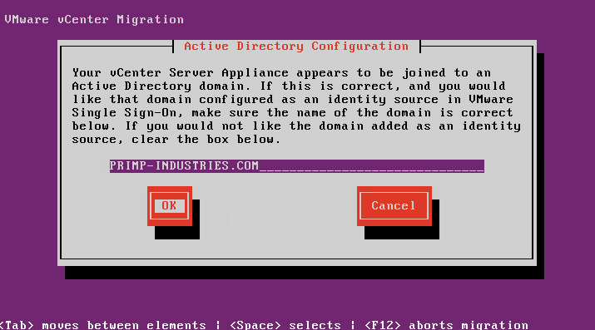
Figure 25 - Configure vSphere SSO Identity Source

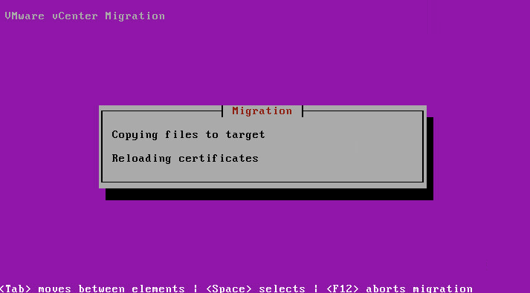
Figure 26 - SSL Certificate copy and reload

- Next, enter the following information:
- Hostname or IP Address of the vCenter Server Database
- Database Name
- Schema name (leave as default dbo unless you have changed it in your environment)
- Username for the vCenter Server Database (tested using “sa”, the SQL Server administrator user; the user entered here must have read permissions for all vCenter tables)
- Password for the vCenter Server Database
- “Migrate stats/events/tasks”: Use the spacebar to check this box and migrate statistics, events, and tasks. Checking this box will increase the time for the migration, depending on the amount of statistics and events in your database. As a rule of thumb, if you have more than 100K entries in any of these tables, we recommend that you not migrate this data.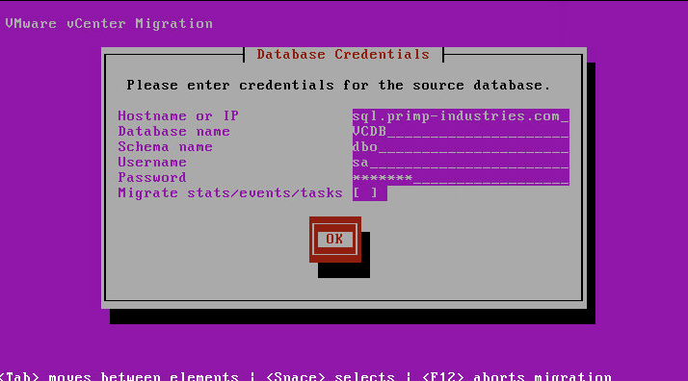
Figure 27 - Source VCDB credentials

During this step, all the data from the Microsoft SQL Server is being copied to the embedded vPostgres database running within the VCSA. The amount of time this takes will depend on the size of your inventory and if you are migrating over your Stats, Events and Tasks tables.

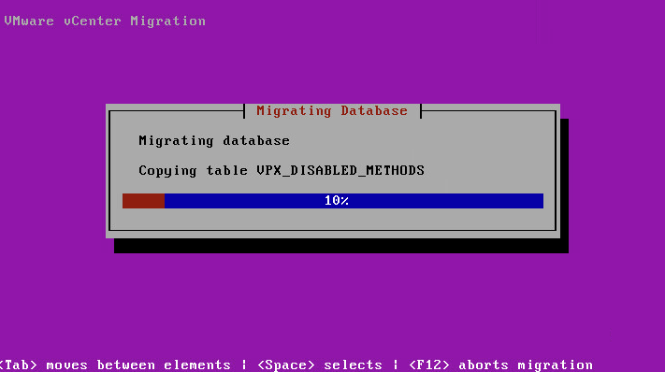
Figure 28 - Migrating database

- Once the migration has successfully completed, select OK to finish the wizard and you will automatically be brought back to the start of the wizard.

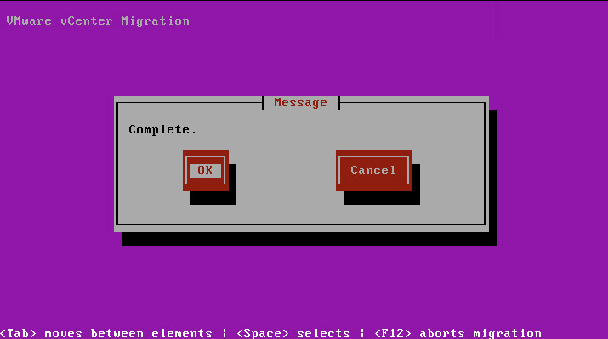
Figure 29 - Migration complete

- At this point, you are almost done! Before logging into your vCenter Server and specifically the vSphere Web Client, you will need to first startup or re-enable all the vSphere Web Client Plugin Solutions. If you have plugins that provide the status of the connection, you should reload or refresh the connection. One example of this is VMware NSX, where you need to ensure the connection is re-established prior to logging into the vSphere Web Client Plugin.

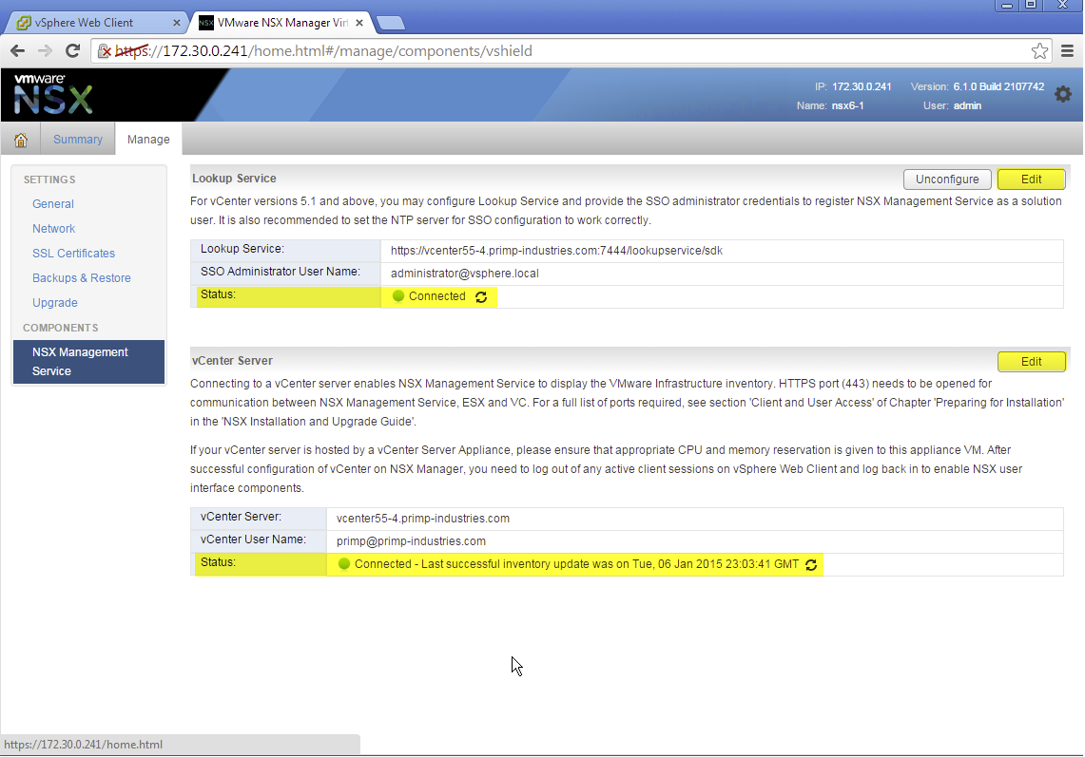
Figure 30 - NSX connectivity to VC

The reason this is required is that the first time you log back into the vSphere Web Client, all your vSphere Web Client Plugins will be downloaded from each of the solutions. For this to succeed, you need to ensure proper communication between the vSphere Web Client Server and each of the solutions. If this is not properly done, then you may not see all your vSphere Web Client Plugins. Once you have restarted you services, you must log out of the vSphere Web Client and then log back in in order to see these services.

- Please close and relaunch your browser before logging into the vSphere Web Client.
- At this point you are now ready to login to your VCSA using the vSphere Web Client. You may notice this may take several minutes depending on the number of vSphere Web Client Plugins you have and the amount of time it takes to download them into the vSphere Web Client Server. Please be patient and do not try to refresh the page, else the process will have to start over.
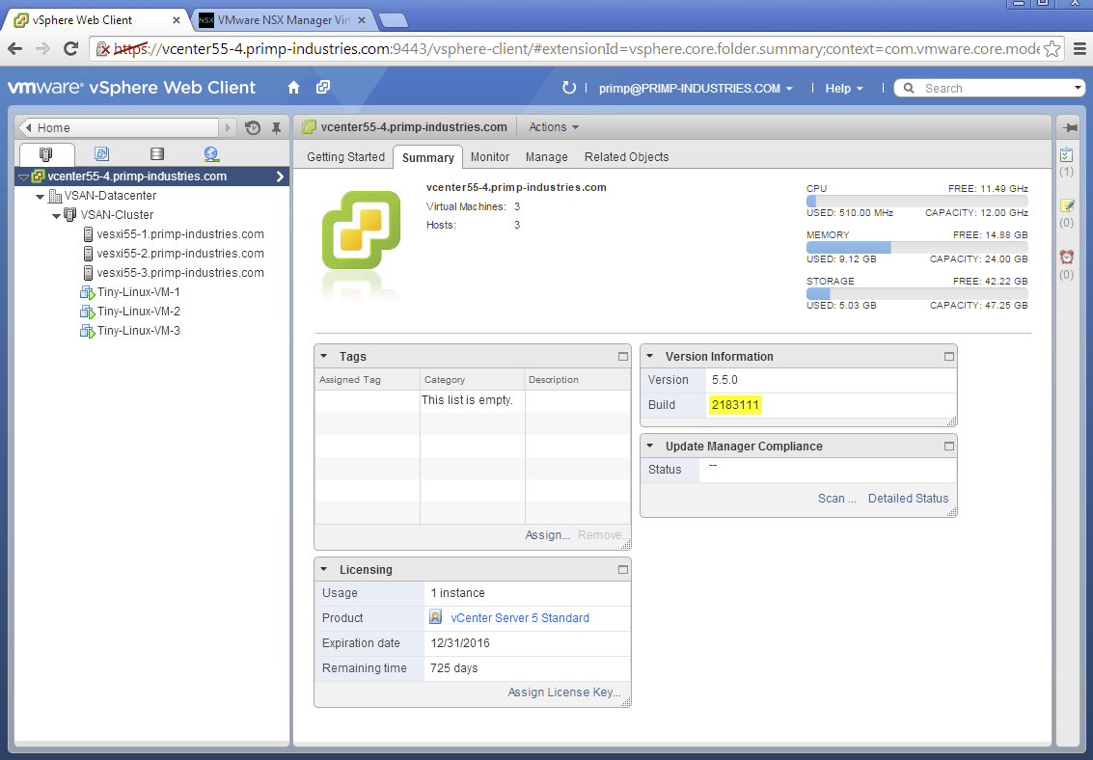
Figure 31 - VCSA Login

Troubleshooting:
In the event of a failed migration or unexpected error, you can simply gain access to your original vCenter Server by powering off the VCSA and powering on the Windows vCenter Server.

If you run into any issues, please post the error in the comments section of the Fling and provide a link to the VCS to VCSA Converter Appliance log file. To access the log, press Alt-F2 at the Converter Appliance console to access the shell, and run “less /var/log/migrate.log” to read the error log (“q” to quit). The log can be copied to another machine running a Secure Shell server with this command:

scp /var/log/migrate.log [user]@[host]:[path]

where [user], [host], and [path] are the username, hostname, and file path for the Secure Shell server, respectively.

